**B.Tech Short Term Industrial/Research Experience Report**

**On**

***Exploratory Multimodal Data Analysis for Understanding the Mental Health Behavioural Pattern***

**By**

**Aditya Sharma**

**(118EI0714)**

Under the supervision of

**Dr. Suchetana Chakraborty**

**At the Department of CSE,**

**IIT Jodhpur**



**Submitted to**

**Dept. of Electronics and Communication Engineering,**

**National Institute of Technology, Rourkela**



**Name: Aditya Sharma**

**Roll No.: 118EI0714**

1. **Certificate of Internship**

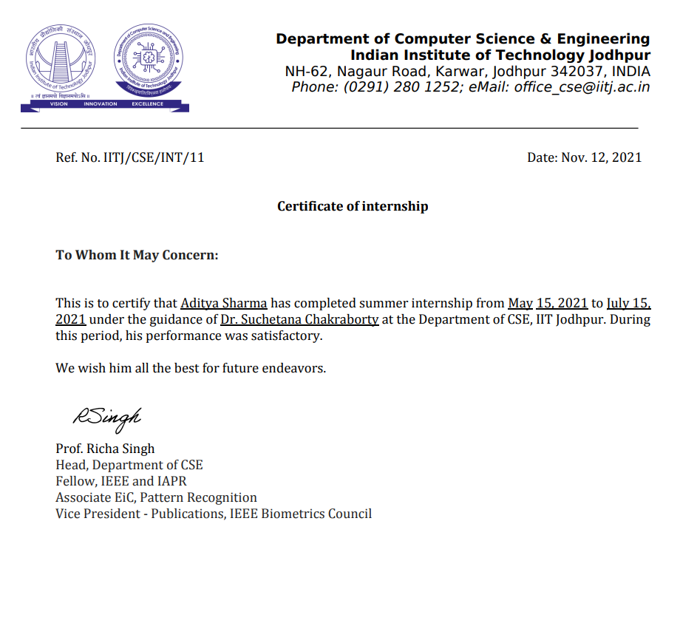

1. **Abstract**

Depression and anxiety are leading causes of disability worldwide but often remain undetected and untreated. Smartphone and wearable devices may offer a unique source of data to detect moment by moment changes in risk factors associated with mental disorders that overcome many of the limitations of traditional screening methods. We can understand the mental health conditions and/or the correlation between the mental and physical health of the users from smartphone app usage metadata. The current research study aimed to explore the extent to which data from smartphone could predict symptoms of depression and anxiety.

1. **Introduction**

Depression and anxiety are the most common causes of disability in the world, with a lifetime prevalence rate of 20%. While the majority of persons with depression and anxiety are treated in primary care settings, more than half of them are not diagnosed or treated appropriately. Given the negative health consequences and expense of untreated diseases, as well as the recent rise in the prevalence of common mental disorders, accurate diagnosis and timely treatment of depression and anxiety has become a top priority.

To assess an individual's mental health, researchers have traditionally relied on questionnaire data delivered by a doctor or self-reported data. These methods, on the other hand, may be limited in their ability to identify the moment-by-moment changes in psychological components that are necessary for preventative measures and prompt interventions. First, questionnaires are frequently conducted infrequently, with significant gaps between them, during which time symptoms can alter dramatically. Second, because these questionnaires frequently rely on retroactive ratings, they are vulnerable to recall bias. Third, respondents may be prone to providing socially desirable responses. Finally, patients usually only see a clinician or have assessments done after their symptoms have developed to a particular level of severity, making prevention much more difficult.

Smartphones may provide a one-of-a-kind opportunity to bypass some of these constraints. Smartphones, which are equipped with a variety of sensors, give an unobtrusive stream of data on an individual's mental health, such as location, smartphone usage habit, physical activity, and social interactions. The term "digital phenotyping" refers to the in-situ quantification of the individual-level human phenotype utilizing data from personal digital devices. A increasing body of evidence suggests that digital phenotyping data can help identify persons who are suffering from or at risk of developing mental problems, often even before symptoms are obvious (or detectable) using traditional approaches.

One source of data that has yielded promising results in identifying those suffering from mental disorders is location data derived from smartphone global positioning systems (GPS). e.g., One of the research found that regularity of participants’ 24-h movement patterns, the variance of locations visited and the proportion of time spent at home were related to depressive symptom severity in a non-clinical population. Also the total distance traveled had a significant negative relationship with clinical manic symptoms in patients diagnosed with bipolar disorder. Finally, in a meta-analytic review of studies assessing the correlation between smartphone and wearable device data and affective disorders, revealed that the association between time spent at home and depressive symptoms was the most consistently significant finding of any smartphone-derived feature in the analysis. Yet, whilst GPS may provide a valuable source of data to predict symptoms of mental ill-health, there may be certain situations in which GPS data is not available (e.g., due to technological limitations or privacy concerns) or when movement is limited (e.g., due to physical ill-health), requiring us to establish other digital phenotyping data sources to aid the identification of symptoms or risk factors associated with mental disorders.

The accelerometer, which is most typically used to assess an individual's physical activity, is the most widely used sensor in wearable devices. There is a considerable amount of evidence showing a link between physical activity and mental health. Vallance et al. showed a robust link between accelerometer-based exercise and lower incidence of depression in one of the largest studies to date using wrist-worn devices to assess physical activity in a population-based sample of 2,862 adults. O'Brien et al. discovered that physical activity was considerably lower in patients diagnosed with depression compared to healthy controls in a clinical examination of older adults diagnosed with depression.

The aim of the current study was to assess to what extent data from smartphone and wearable devices may be used to predict symptoms of depression, anxiety and stress during periods of restricted movement. The study was conducted during the first wave of the corona virus disease 2019 (COVID-19) pandemic as governments across the world instated widespread restrictions on individual movement and social interaction intended to reduce the incidence of the virus. This provided an opportunity to assess the role of GPS in predicting symptoms of depression and anxiety during periods of limited movement and examine the predictive power of other digital phenotyping data sources. We sought to answer the following questions:

1. Can location features derived from smartphone GPS data be used to predict symptoms of depression and anxiety? i.e., do previous findings replicate during periods of restricted movement?
2. Can measures of physical activity derived from accelerometer and gyroscope data be used to predict symptoms of depression and anxiety?
3. Can duration of smartphone usage data be used to predict symptoms of depression and anxiety?
4. Which digital phenotyping variables have the strongest predictive power?
5. For establishing the ground truth individuals will be asked to provide self-reported mood history that is how they are feeling today.
6. **Assigned Tasks**

The tasks assigned to me during my internship tenure were:

1. To explore existing datasets and research studies available online and perform analysis on them for establishing the proposed hypothesis and developing a research model. Perform exploratory data analysis to find out the features and ground truths for the study.
2. Design and develop a smartphone app for data collection.
3. **Data Analysis Part**

Data analytics is the process of exploring and analyzing large datasets to make predictions and boost data-driven decision making. Data analytics allows us to collect, clean, and transform data to derive meaningful insights. It helps to answer questions, test hypotheses, or disprove theories.

The research was in the initial phase and to establish the proposed hypothesis and features and ground truths for the study, I was given the task to analyze existing datasets available to find the features that can be measured using smartphone sensors and which have strongest correlation with mental health parameters.

I used python language and various python libraries like Numpy, Pandas, SciPy, Matplotlib, Scikit-learn etc for importing the datasets, cleaning and preparing the data, summarizing the data frame and finding correlation between different features, model development and model evaluation.

Some of the analyzed datasets with the results obtained are shown below:

1. **Academic Stress and Smartphone Dependence (**[**link**](https://data.mendeley.com/datasets/gdyw68pbs5/1)**):**

Linear regression analysis was used to investigate the relationship among the variables. The results showed that academic stress was positively related to psychological distress, which may further lead to severe smartphone dependence. Psychological distress partially mediated the relationship between academic stress and smartphone dependence. The mediating effect of psychological distress between academic stress and smartphone dependence was moderated by academic resilience. Specifically, academic resilience weakened the indirect relationship between academic stress and smartphone dependence that was mediated by psychological distress.

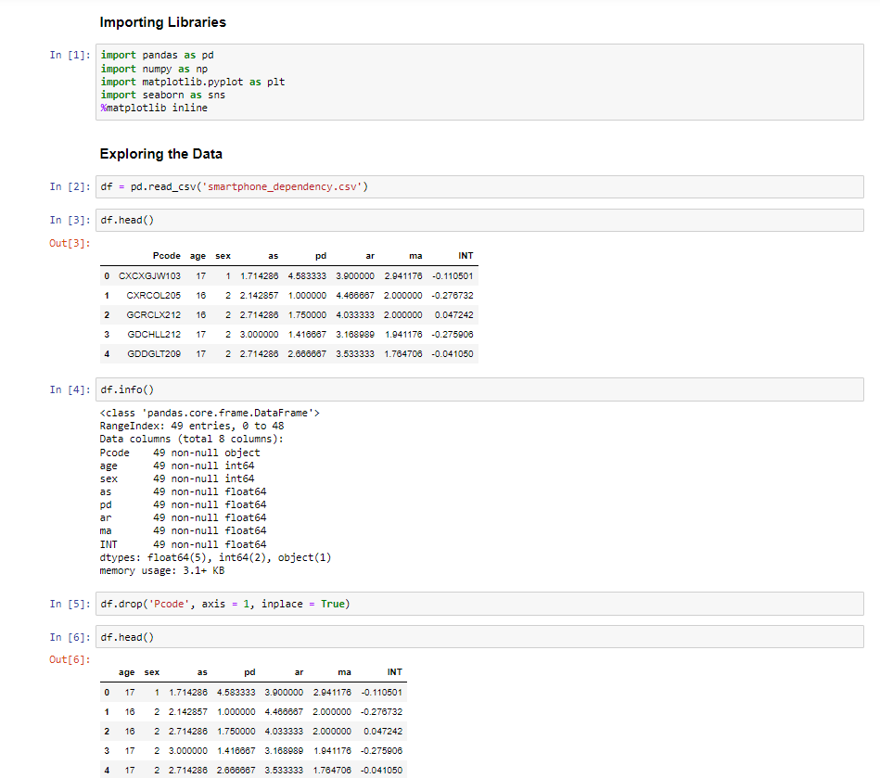 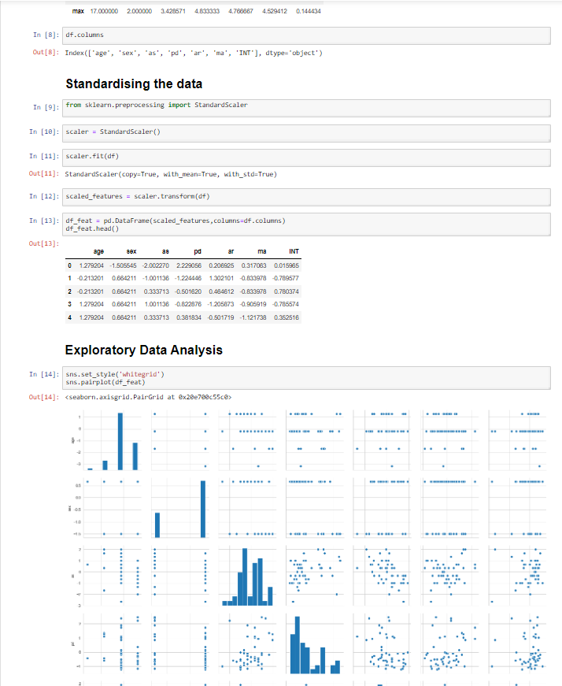

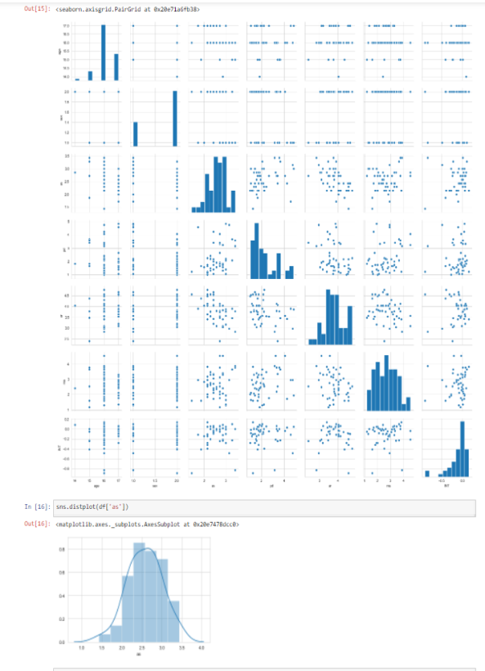 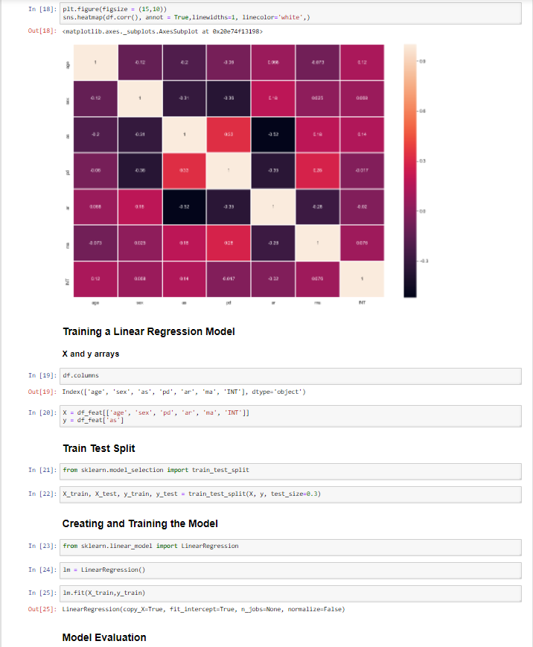

Fig: Screenshots of the EDA performed

* **Observations:** The results showed that academic stress was positively related to psychological distress, which may further lead to severe smartphone dependence. Psychological distress partially mediated the relationship between academic stress and smartphone dependence. The mediating effect of psychological distress between academic stress and smartphone dependence was moderated by academic resilience. Specifically, academic resilience weakened the indirect relationship between academic stress and smartphone dependence that was mediated by psychological distress.

1. **Depression, anxiety, and smartphone addiction in university students- A cross sectional study (**[**link**](IIT%20Jodhpur%20Internship/latest%20dataset%20Smartphone%20addiction/S1Dataset.csv)**) :**

The dataset aims to assess prevalence of smartphone addiction symptoms, and to ascertain whether depression or anxiety, independently, contributes to smartphone addiction level among a sample of university students, while adjusting simultaneously for important sociodemographic, academic, lifestyle, personality trait, and smartphone-related variables. A random sample of 688 undergraduate university students (mean age = 20.64 ±1.88 years;53% men) completed a survey composed of a) questions about socio-demographics, academics, lifestyle behaviors, personality type, and smartphone use-related variables; b) 26-item Smartphone Addiction Inventory (SPAI) Scale; and c) brief screeners of depression and anxiety (PHQ-2 and GAD-2), which constitute the two core DSM-IV items for major depressive disorder and generalized anxiety disorder, respectively.

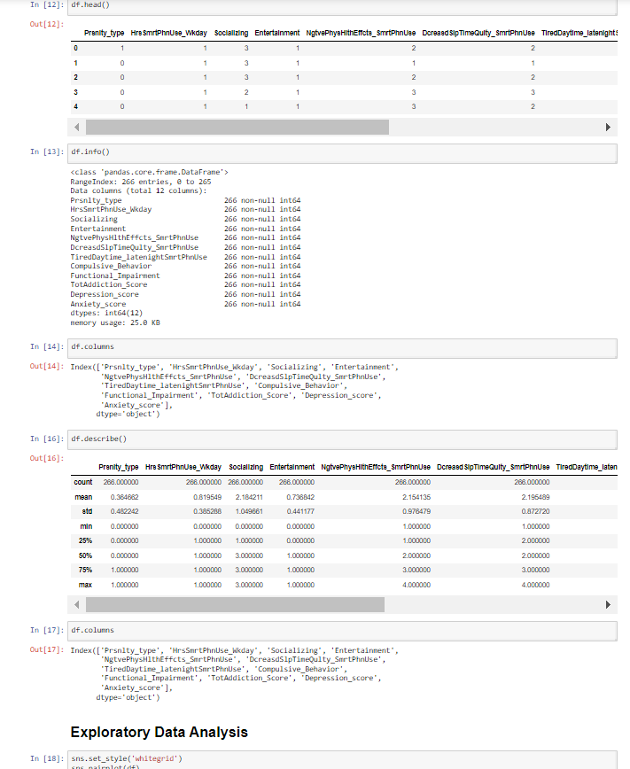 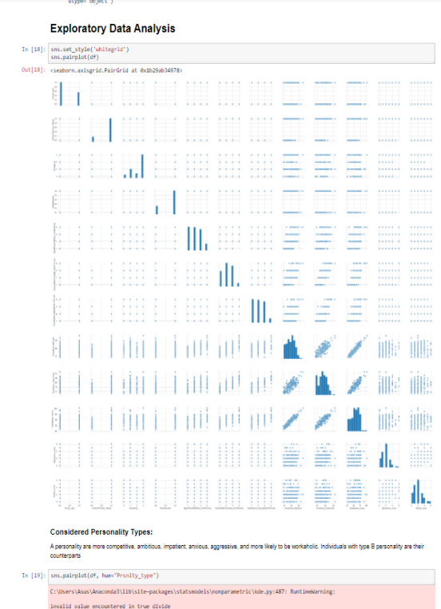

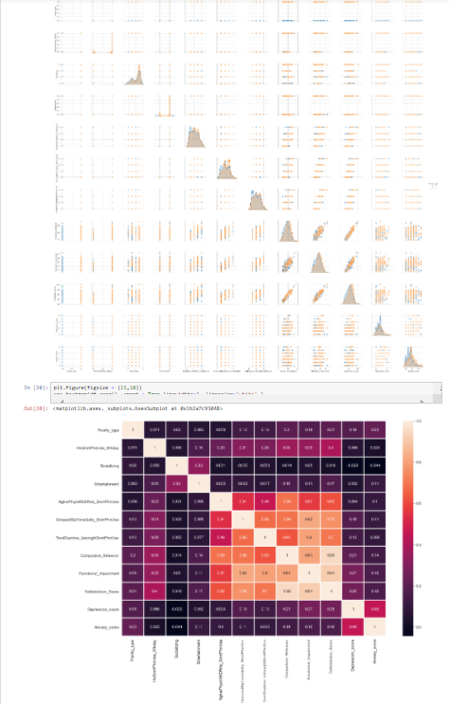 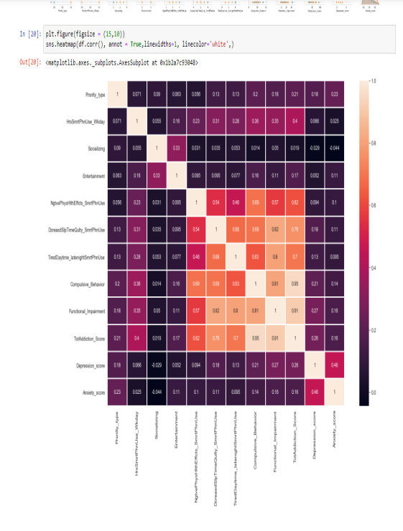

Fig: Screenshots of the EDA performed

* **Observations:** -> Prevalence rates of smartphone-related compulsive behavior, functional impairment, tolerance and withdrawal symptoms were substantial.  
  -> Depression and anxiety scores emerged as independent positive predictors of smartphone addiction, with depression score being a more powerful predictor compared to anxiety score  
  -> Personality type A, class (year 2 vs. year 3), younger age at first smartphone use, excessive use during a weekday, using it for entertainment and not using it to call family members, and having depression or anxiety, showed statistically significant associations with smartphone addiction.

1. **Link to some other analyzed datasets and their results is ->** [**click here**](https://github.com/66aditya99/Data-Analysis-IIT-Jodhpur-Internship)
2. **Data Collection and Application Development Part**

We developed a smartphone application for collecting data from users. Figure 3 presents screenshots of the application. The application provides an intuitive interface for users to input their moods, and activity information.

The following data are collected by the application:

* Global Positioning System (GPS) data
* Battery Level
* App Usage History
* Accelerometer Data
* Gyroscope Data

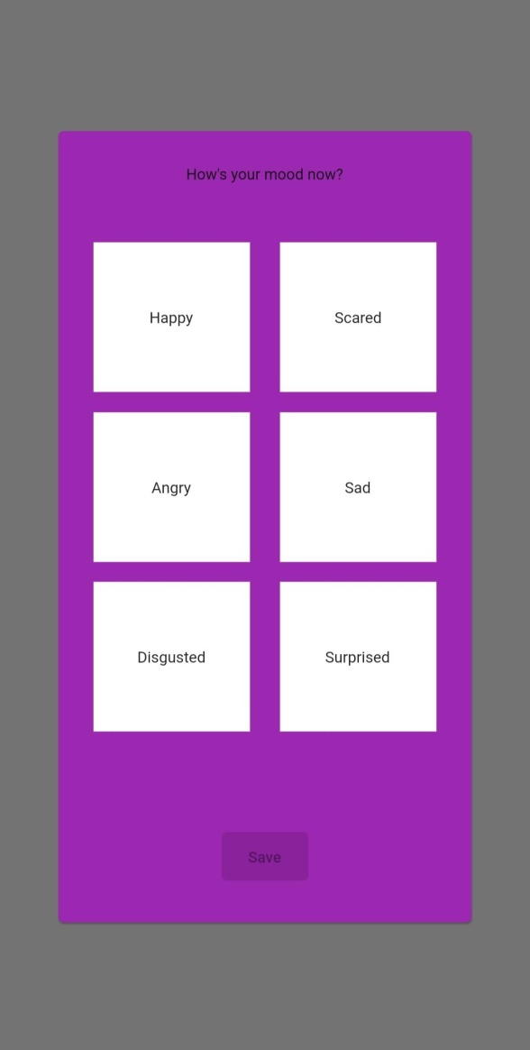 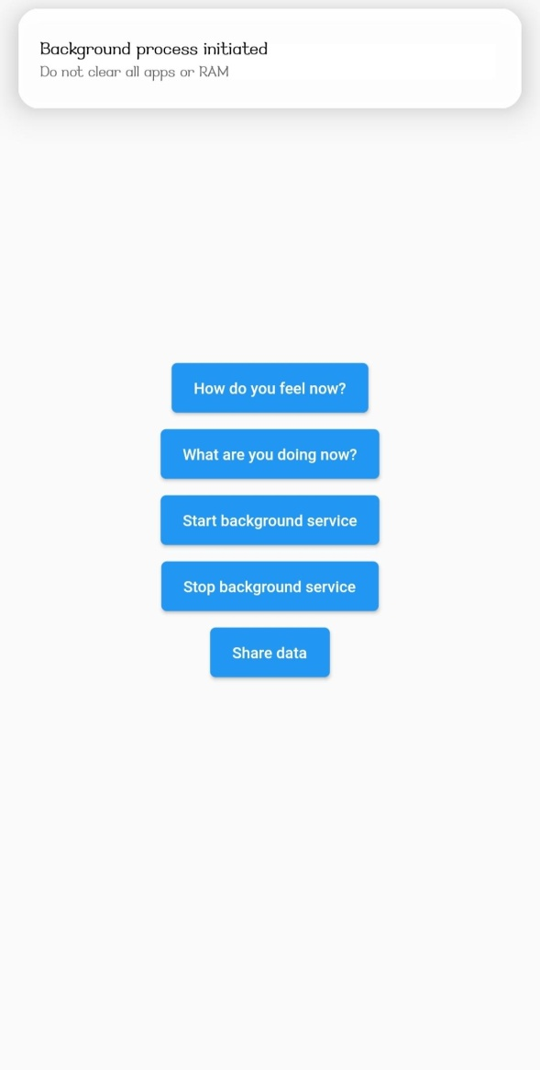

Fig 3: Screenshots of the Mobile application

1. **Conclusion**

To assess an individual's mental health, researchers have traditionally relied on questionnaire data delivered by a doctor or self-reported data. These methods, on the other hand, may be limited in their ability to identify the moment-by-moment changes in psychological components that are necessary for preventative measures and prompt interventions. Smartphones may provide a one-of-a-kind opportunity to bypass some of these constraints. Smartphones, which are equipped with a variety of sensors, give an unobtrusive stream of data on an individual's mental health, such as location, smartphone usage habit, physical activity, and social interactions. During this study we performed data analysis on various datasets and found out that GPS data (location variance on depression), sleep time, accelerometer data (physical activity), heart rate, sociability were able to predict symptoms of depression and anxiety. By analyzing different datasets we found that GPS data, sociability, sleep time, physical activity have some negative correlation with depression which means the more a person do these activities the less depressed he/she tends to be. Based on the features found, a smartphone application was designed for data collection.

1. **References**
2. World Health Organization. Depression and Other Common Mental Disorders: Global Health Estimates. Geneva(2017).Available online at: https://www.who.int/mental_health/management/depression/prevalence_global_health_estimates/en/ (accessed April 12, 2020).
3. Mental Health - Household Pulse Survey - COVID-19. (2020). Available online at: https://www.cdc.gov/nchs/covid19/pulse/mental-health.htm
4. Smartphone sensing methods for studying behavior in everyday life (2017) available at: <http://dx.doi.org/10.1016/j.cobeha.2017.07.018>
5. Patterns of behavior change in students over an academic term: A preliminary study of activity and sociability behaviors using smartphone sensing methods (2016) available at: <https://www.journals.elsevier.com/computers-in-human-behavior>
6. DeepMood: Forecasting Depressed Mood Based on Self-Reported Histories via Recurrent Neural Networks (2017) available at: <https://dl.acm.org/doi/10.1145/3038912.3052676>
7. Mental health monitoring with multimodal sensing and machine learning: A survey (2018) available at: <https://www.journals.elsevier.com/pervasive-and-mobile-computing>
8. The Jigsaw Continuous Sensing Engine for Mobile Phone Applications (2010)
9. Depression, anxiety, and smartphone addiction in university students- A cross sectional study (2017) available at: <https://journals.plos.org/plosone/article?id=10.1371/journal.pone.0182239>
10. StudentLife: Assessing Mental Health, Academic Performance and Behavioral Trends of College Students using Smartphones and StudentLife Dataset 2014. <http://studentlife.cs.dartmouth.edu/>.
11. SmartGPA: How Smartphones Can Assess and Predict Academic Performance of College Students
12. Vallance JK, Winkler EAH, Gardiner PA, Healy GN, Lynch BM, Owen N. Associations of objectively-assessed physical activity and sedentary time with depression: NHANES (2005-2006).
13. O’Brien JT, Gallagher P, Stow D, Hammerla N, Ploetz T, Firbank M, et al. A study of wrist-worn activity measurement as a potential realworld biomarker for late-life depression. Psychol Med. (2017) 47:93–102. doi: 10.1017/S0033291716002166